**Interfacing LCD to 8051**

**Lab #10**



Spring 2022

CSE-307L Microprocessor Based system Design

Submitted by: **Ashfaq Ahmad**

Registration No: **19PWCSE1795**

Class Section: **B**

“On my honor, as student of University of Engineering and Technology, I have neither given nor received unauthorized assistance on this academic work.”

Student Signature: ______________

Submitted to:

**Dr: Aber Irfan sab**

**August** 02, 2022

**Department of Computer Systems Engineering**

**University of Engineering and Technology, Peshawar**

**Task 01:** Write a program for Microcontroller That Display your Name on LCD.

**Source Code:**

#include <reg51.h>

#include <stdio.h>

sbit E=P3^6;

sbit RS=P3^7;

void delay(unsigned int x)

{

   unsigned int i;

   for(i=0; i<x; i++);

}

void writedata(char u)

{

   RS=1;         //1 to select data register.

   P2=u;

   E=1;        //when 1  it latch information from data register to LCD.

   delay(400);

   E=0;          // LCD become clear

   delay(400);

}

void writecmd(int z)

{

   RS=0;   //RS=0 to select command register

   P2=z;

   E=1;      //when 1  itlatch information from command register to LCD.

   delay(400);

   E=0;

   delay(400);

}

void lcd_init()

{

   writecmd(0x0C);  //display on,cursor off

   writecmd(0x01);  //clear display screen

   writecmd(0x06);  //increment cursor to right.

}

void name()

{

    writedata('A');

    writedata('S');

    writedata('H');

    writedata('F');

    writedata('A');

    writedata('Q');

    writedata(' ');

   writedata('A');

    writedata('H');

    writedata('M');

   writedata('A');

    writedata('D');

   writedata(' ');

   writedata('M');

    writedata('S');

    writedata('D');

}

   void microcontroller_init(void)

   {

      P1=0xf0;

      delay(200);

      P2=0x00;

      delay(200);

      P3=0x00;

      delay(200);

   }

void main(void)

 {

    microcontroller_init();

    lcd_init();

     while(1)

     {

    name();

     }

 }

**Output:**

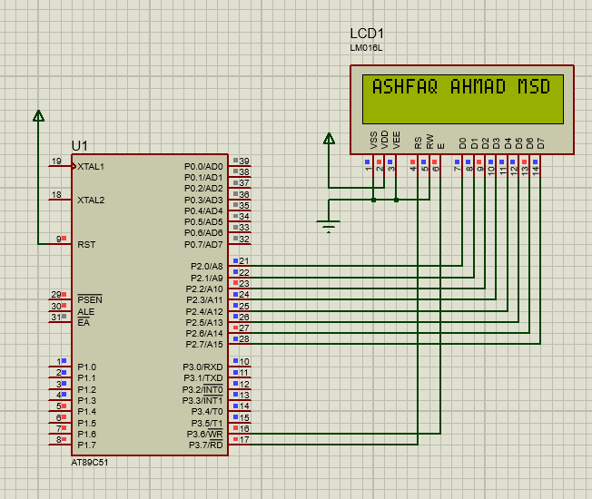

**Task02: Write a Program for simple Calculator that Display Result on LCD.**

**Source Code:**

/* Main.c file generated by New Project wizard

 *

 * Created:   Tue Jun 14 2022

 * Processor: AT89C51

 * Compiler:  Keil for 8051

 */

#include <reg51.h>

#include <stdio.h>

//Function declarations

void cct_init(void);

void delay(int);

void lcdinit(void);

void writecmd(int);

void writedata(char);

void Return(void);

char READ_SWITCHES(void);

char get_key(void);

//*******************

//Pin description

/*

P2 is data bus

P3.7 is RS

P3.6 is E

P1.0 to P1.3 are keypad row outputs

P1.4 to P1.6 are keypad column inputs

*/

//********************

// Define Pins

//********************

sbit RowA = P1^0; //RowA

sbit RowB = P1^1; //RowB

sbit RowC = P1^2; //RowC

sbit RowD = P1^3; //RowD

sbit C1 = P1^4; //Column1

sbit C2 = P1^5; //Column2

sbit C3 = P1^6; //Column3

sbit C4 = P1^7; //Column4

sbit E = P3^6; //E pin for LCD

sbit RS = P3^7; //RS pin for LCD

unsigned int key_count = 0, result_int;

char array[3], result_char;

// ***********************************************************

// Main program

//

int main(void)

{

 char key; // key char for keeping record of pressed key

 cct_init(); // Make input and output pins as required

 lcdinit(); // Initilize LCD

 while(1)

 {

 key = get_key(); // Get pressed key

if (key == 'C')

{

writecmd(0x01); // Clear screen

array[0]= array[1]= array[2]='n';

result_int = 0; key_count = 0;

}

else if(key == '=')

{

writedata(key); // Echo the key pressed to LCD

if(array[1] == 'x')

result_int = (array[0] -'0') * (array[2] - '0');

else if(array[1] == '/')

result_int = (array[0] -'0') / (array[2] - '0');

else if(array[1] == '+')

result_int = (array[0] -'0') + (array[2] - '0');

else if(array[1] == '-')

result_int = (array[0] -'0') - (array[2] - '0');

if(result_int > 9) //if the result is greater than 9 then we need to store each digit in an array

{

 int result[2]; //Delare an array

 result[0] = result_int/10; //Store the digit at ten's place at index 0

 result[1] = result_int%10; //Store the digit at unit's place at index 1

 result_char = (char)result[0] + '0';//Convert the integer at index 0 to character

 writedata(result_char ); // Echo the key pressed to LCD

 result_char = (char)result[1] + '0';//Convert the integer at index 1 to character

 writedata(result_char ); // Echo the key pressed to LCD

}

else

{

 result_char = (char)result_int + '0';

 writedata(result_char ); // Echo the key pressed to LCD

}

}

else

writedata(key); // Echo the key pressed to LCD

 }

}

void cct_init(void)

{

                P0 = 0x00; //not used

                P1 = 0xf0; //used for generating outputs and taking inputs from Keypad

                P2 = 0x00; //used as data port for LCD

                P3 = 0x00; //used for RS and E

}

void delay(int a)

{

                 int i;

                 for(i=0;i<a;i++); //null statement

}

void writedata(char t)

{

                 RS = 1; // This is data

                 P2 = t; //Data transfer

                 E = 1; // => E = 1

                 delay(150);

                 E = 0; // => E = 0

                 delay(150);

}

void writecmd(int z)

{

                 RS = 0; // This is command

                 P2 = z; //Data transfer

                 E = 1; // => E = 1

                 delay(150);

                 E = 0; // => E = 0

                 delay(150);

}

void lcdinit(void)

{

                 ///////////// Reset process from datasheet /////////

                 delay(15000);

                 writecmd(0x30);

                 delay(4500);

                 writecmd(0x30);

                 delay(300);

                 writecmd(0x30);

                 delay(650);

                 /////////////////////////////////////////////////////

                 writecmd(0x38); //function set

                 writecmd(0x0c); //display on,cursor off,blink off

                 writecmd(0x01); //clear display

                 writecmd(0x06); //entry mode, set increment

}

void Return(void) //Return to 0 location on LCD

{

                 writecmd(0x02);

                 delay(1500);

}

char READ_SWITCHES(void)

{

                RowA = 0; RowB = 1; RowC = 1; RowD = 1; //Test Row A

                if (C1 == 0) { delay(10000); while (C1==0); return '7'; }

                if (C2 == 0){ delay(10000); while (C2==0); return '8'; }

                if (C3 == 0) { delay(10000); while (C3==0); return '9'; }

                if (C4 == 0) { delay(10000); while (C4==0); return '/'; }

                RowA = 1; RowB = 0; RowC = 1; RowD = 1; //Test Row B

                if (C1 == 0) { delay(10000); while (C1==0); return '4'; }

                if (C2 == 0) { delay(10000); while (C2==0); return '5'; }

                if (C3 == 0) { delay(10000); while (C3==0); return '6'; }

                if (C4 == 0) { delay(10000); while (C4==0); return 'x'; }

                RowA = 1; RowB = 1; RowC = 0; RowD = 1; //Test Row C

                if (C1 == 0) { delay(10000); while (C1==0); return '1'; }

                if (C2 == 0) { delay(10000); while (C2==0); return '2'; }

                if (C3 == 0) { delay(10000); while (C3==0); return '3'; }

                if (C4 == 0) { delay(10000); while (C4==0); return '-'; }

                RowA = 1; RowB = 1; RowC = 1; RowD = 0; //Test Row D

                if (C1 == 0) { delay(10000); while (C1==0); return 'C'; }

                if (C2 == 0) { delay(10000); while (C2==0); return '0'; }

                if (C3 == 0) { delay(10000); while (C3==0); return '='; }

                if (C4 == 0) { delay(10000); while (C4==0); return '+'; }

                return 'n'; // Means no key has been pressed

}

char get_key(void) //get key from user

{

                char key = 'n'; //assume no key pressed

                while(key=='n') //wait untill a key is pressed

                key = READ_SWITCHES(); //scan the keys again and again

                array[key_count++]= key;

                return key; //when key pressed then return its value

}

**Output:**

